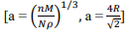
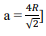
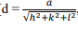
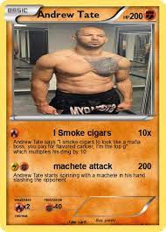

=
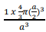
For simple cubic

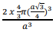
For BCC (big chintu ___ )
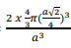
For FCC ( melody khau khud jan jao)



David mullers
